Results for retreiving command:

1. #Find all the unique 'Wind Speed' values in the data.

print(data['Wind Speed_km/h'].unique())

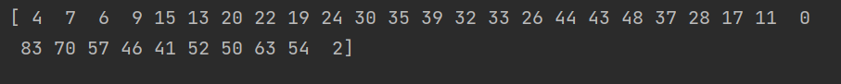

2. #Find the number of times when the 'Weather is exactly Clear'

#view_counts()

print(data.Weather.value_counts())

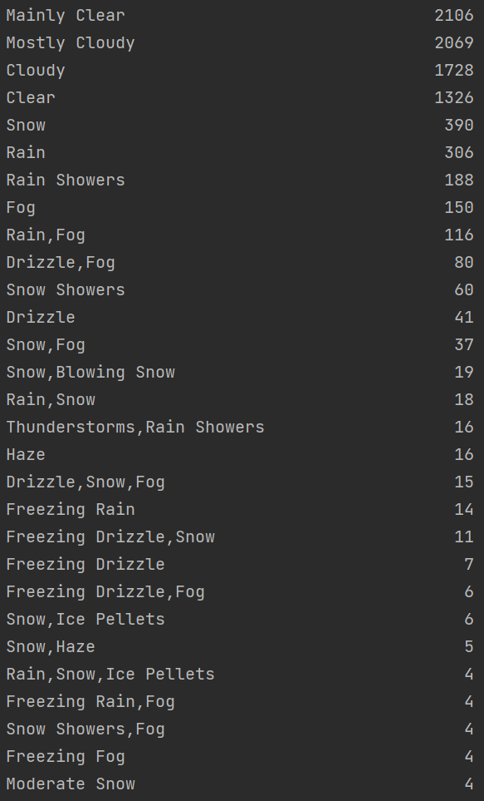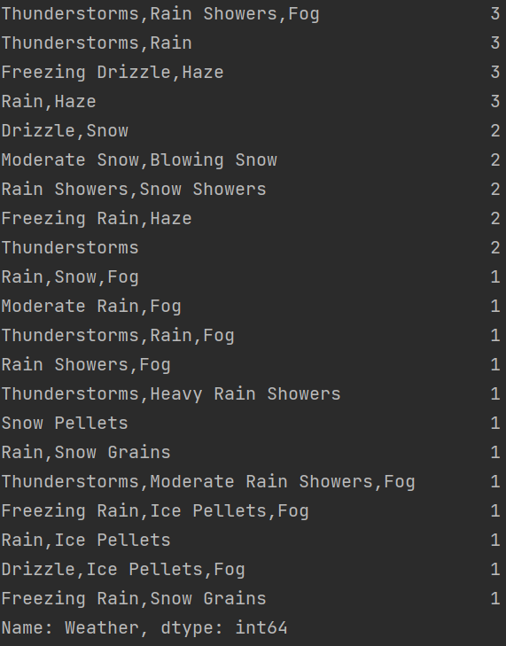

#filtering  
print(data[data.Weather=='Clear'])

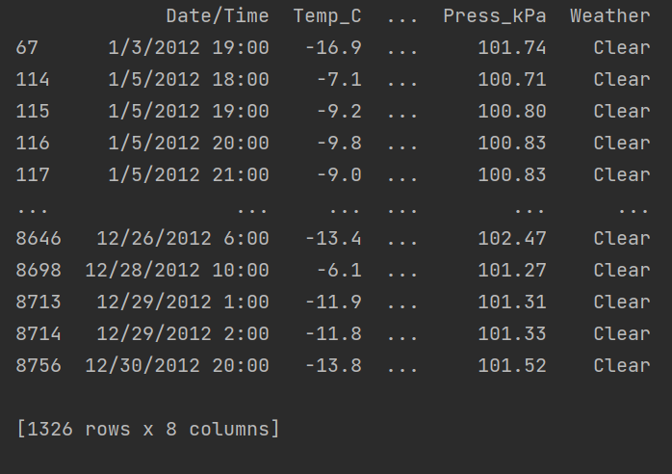

#groupby  
#print(data.groupby('Weather').get_group('Clear'))

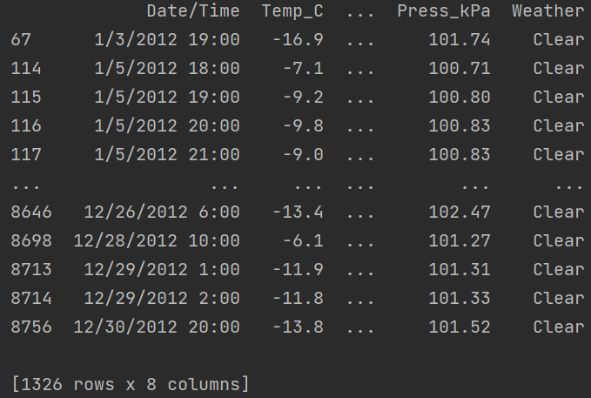

#Find the number of times when the 'Wind Speed was exactly 4 km/h'.  
#print(data[data['Wind Speed_km/h']==4])

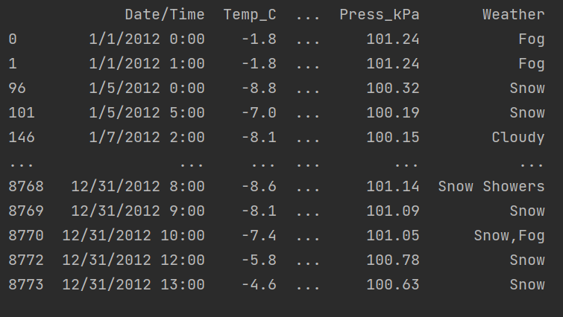

#Find out all the Null Values in the data.  
#print(data[data.isnull()])

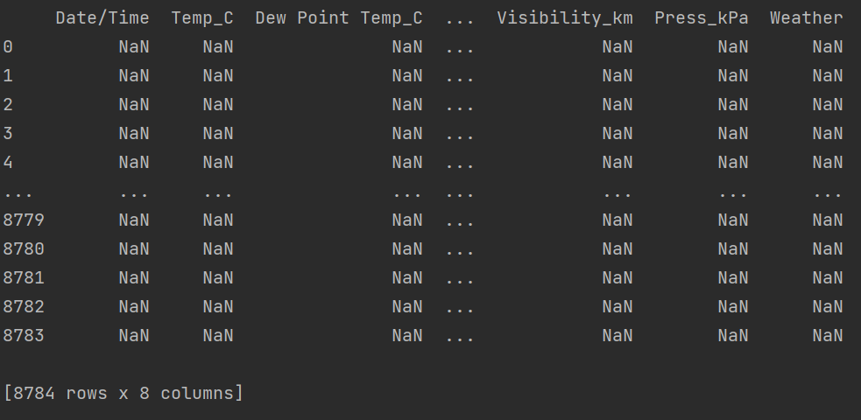

#What is the mean 'Visibility' ?  
#print(data.Visibility_km.mean())



#What is the Standard Deviation of 'Pressure' in this data?  
#print(data.Press_kPa.std())



#What is the Variance of 'Relative Humidity' in this data ?  
#print(data['Rel Hum_%'].var())

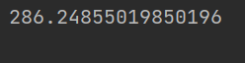

#Find all instances when 'Snow' was recorded.  
#value_counts()  
#print(data['Weather'].value_counts())

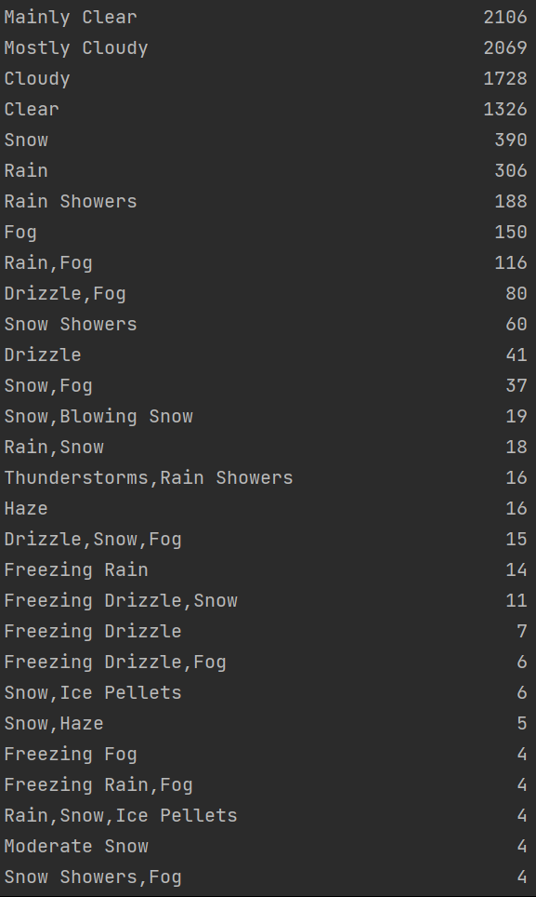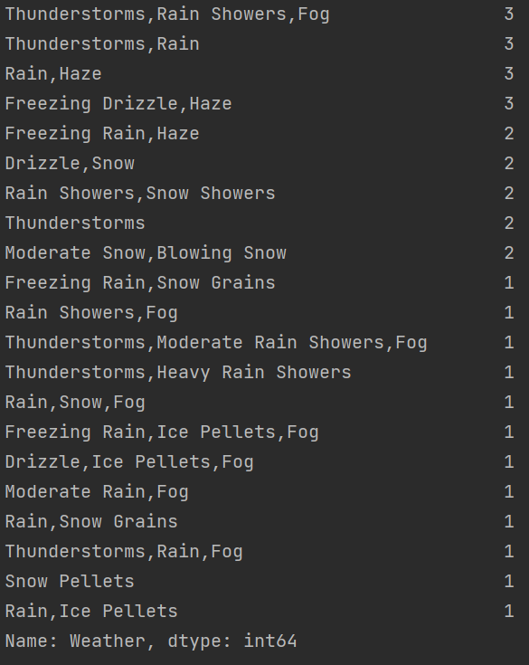

#filtering  
#print(data[data['Weather']=='Snow'])

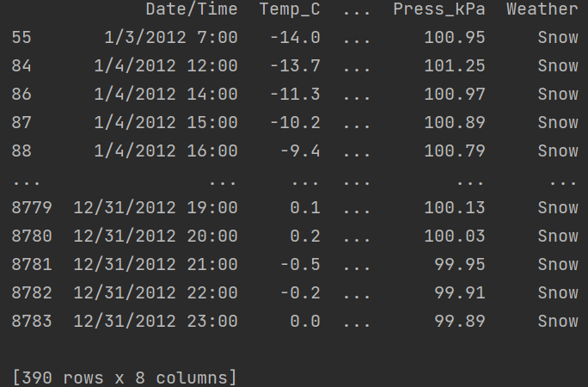

#str.contains()  
#print(data[data['Weather'].str.contains('Snow')])

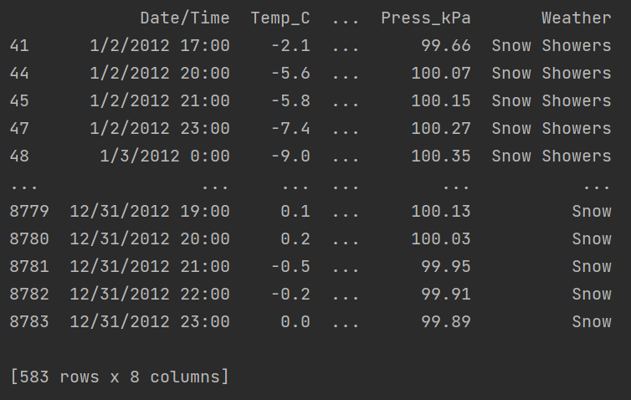

# What is the Mean value of each column against each 'Weather Condition ?  
#print(data.groupby('Weather').mean())

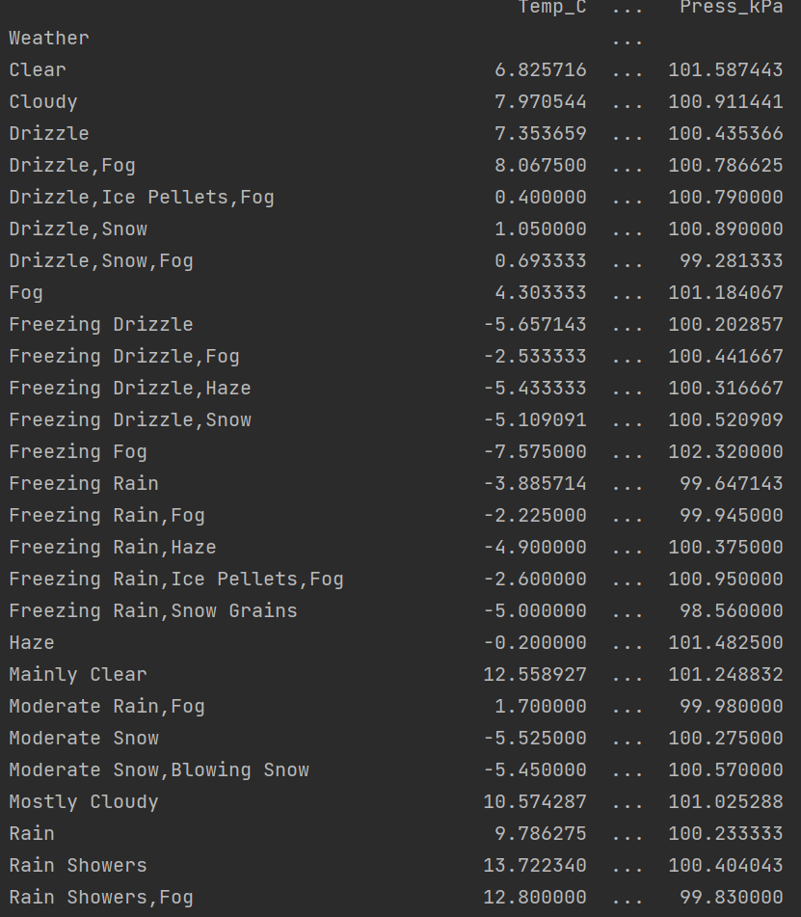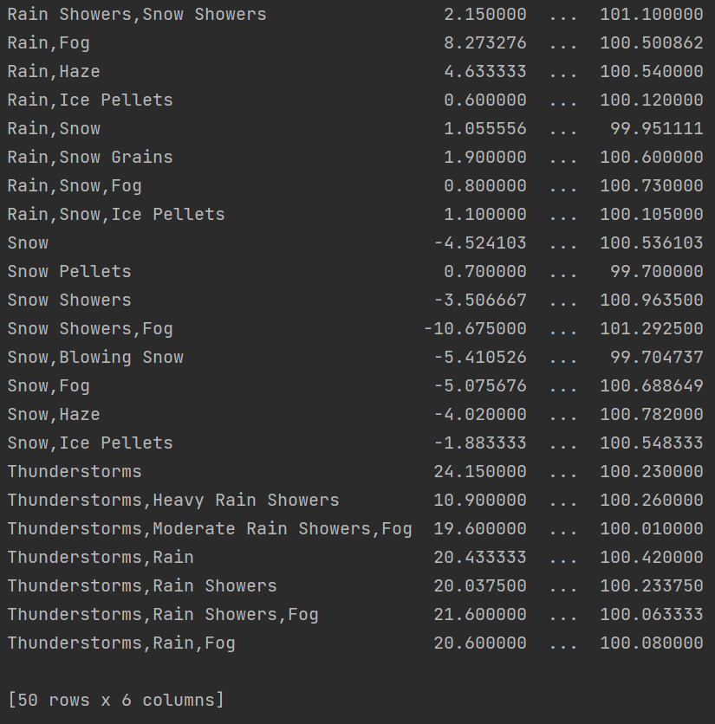

#What is the Minimum & Maximum value of each column against each 'Weather Condition  
#print(data.groupby('Weather').min())  
#print(data.groupby('Weather').max())

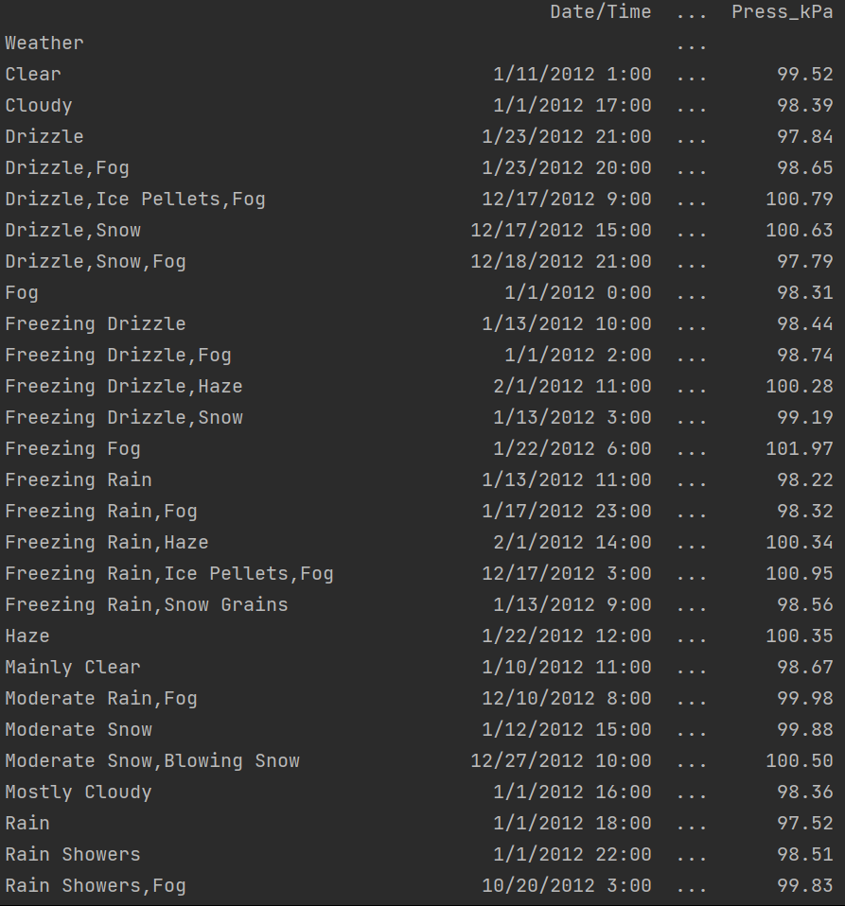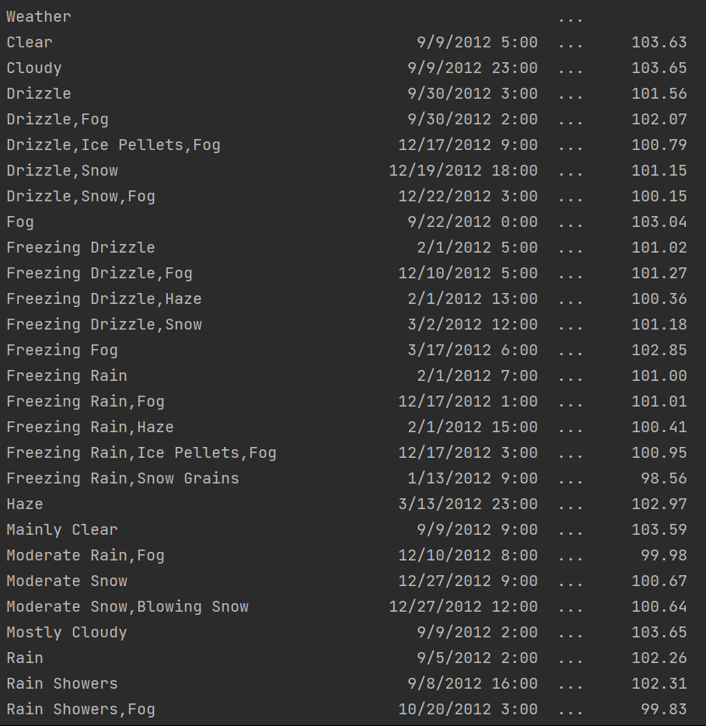

#Show all the Records where Weather Condition is Fog.  
#print(data[data['Weather']=='Fog'])

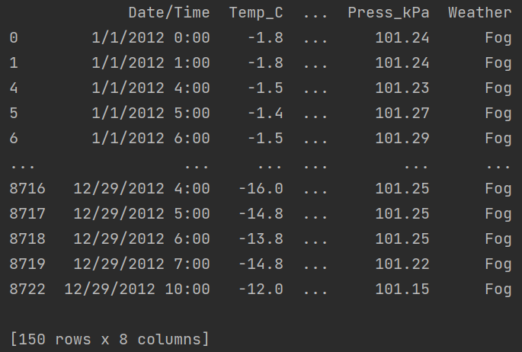

#Find all instances when 'Weather is Clear' or 'Visibility is above 40'.  
#print(data[(data['Weather']=='Clear') | (data['Visibility_km']>40)])

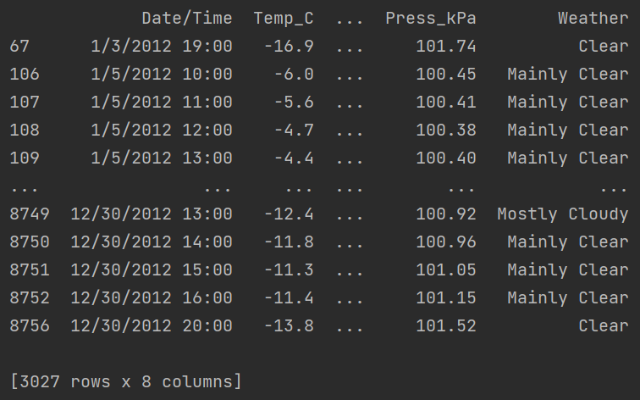

#Find all instances when :  
#A. 'Weather is Clear' and 'Relative Humidity is greater than 50'  
#or  
#B. 'Visibility is above 40'  
  
#print(data[ (data['Weather']=='Clear') & (data['Rel Hum_%']>50) | (data['Visibility_km']>40) ])

